Impact of Digitalization on Customers’ Well-Being in the
Pandemic Period: Challenges and Opportunities for the
Retail Industry

Abstract: Order increases, supply chain disruptions, changing customer behavior, store closures, and more that have been caused by the coronavirus epidemic (COVID-19) will undoubtedly affect the online commerce forms of business. The coronavirus pandemic has a significant impact on digitalization and customer experience and well-being in mobile commerce. Since the beginning of the coronavirus pandemic, online sales and the number of online shoppers using wireless internetenabled devices have increased tremendously. The article develops, an experimental study that captures COVID-19 and digital commerce’s impact in terms of customers’ experience and well-being during the pandemic period. The study explores the synergy between technology evolution and the effects of the COVID-19 pandemic on customers’ behavior based on survey data collection and the technology acceptance model (TAM). The results reveal that, for millennials, digital commerce seems to be the typical way of shopping and paying in the pandemic period since the oldest generations adopted in a smaller proportion the use of mobile devices for shopping and payments. Besides, retailers are confronted with great challenges raised by millennials’ expectations. The result confirms four of the six hypotheses based on the technology acceptance model (TAM). As a result, it shows that the easiness of use, trust, mobility, and customer involvement influences the behavioral intention of the customer to use mobile commerce, and that usefulness and customization does not influence
the behavioral intention.

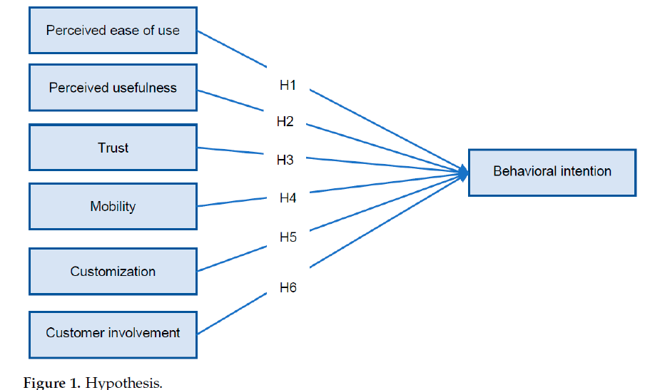

The Impact of Digital Marketing vs. Traditional Marketing on Consumer Buying Behavior
Objectives: This research aims to measure the impact of digital marketing vs. traditional marketing on consumer behavior by analyzing their motives and reasons related to the orientation and purchase of products or services through social media and identifying the differences in marketing strategies used depending on the demographics of respondents. Methods: The research was realized based on primary data. For the realization of the research objectives and questions, a quantitative method was used, where 400 citizens of Kosovo were a part of the research. Findings: Based on the ordinary least squares (OLS) model, it turned out that the two marketing types impact consumer buying behavior, but digital marketing turned out to be the indicator with the greatest impact on deciding to make purchases. Also, based on the t-test and ANOVA, there was no significant difference in using traditional and digital marketing types depending on demographic variables. Novelty/improvement: Through this research, businesses receive comments on the preferences of citizens for the marketing type and the possible offers depending on the preferences, as well as the impact of traditional and digital marketing on the purchasing behavior of consumers.

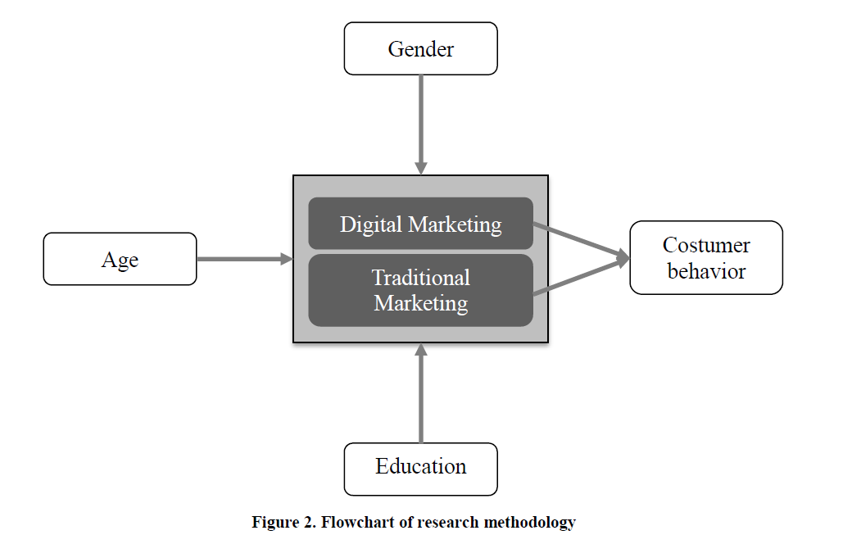

Impact of Music and Colour on Customers’ Emotional States: An Experimental Study of Online Store

Retailers try their best to make their online store environment more entertaining and attractive to capture customers’ attention. Therefore, it is interesting and beneficial to explore how the store environment impacts the customer emotions in store and how these emotions change customer’s buying behavior. The main focus of this study is to measure the impact of atmosphere cues, such as color and music on respondent’s emotional response and their shopping behavior in an online store. Respondents were exposed to different combinations of music and color, and both cues had significant impacts on the respondent’s emotional response and behavioral intention. The questionnaire responses of 230 valid respondents from Pakistan revealed that cool colors and fast tempo music showed greater levels of pleasure and arousal as compared to slow tempo music with warm colors. Arousal and pleasure were also found to be significant parameters for predicting behavior intention. Respondent’s in fast tempo music with cool color environment showed more approach behavior in comparison to slow tempo music with warm colors. An efficient online store environment is proposed, incorporating suitable music and color attributes that will result in more time spent in-store, repurchasing, and revisiting. The outcomes of the study assist online retailers in Pakistan to make the shopping environment attractive and enjoyable.

